Aim: To Create AWS Account and IAM Roles.
The AWS Free Tier account provides new users with free access to range of Amazon Web Services for 6 months, allowing them to explore and test AWS offerings without any upfront cost. The key benefits of AWS Free Tier include the ability to learn and experiment with AWS services, deploy and develop applications at no cost, and explore cloud solutions with minimal risk.

AWS Free Tier Account Setup:
- Visit the AWS Free Tier Page: Go to the AWS Free Tier page.
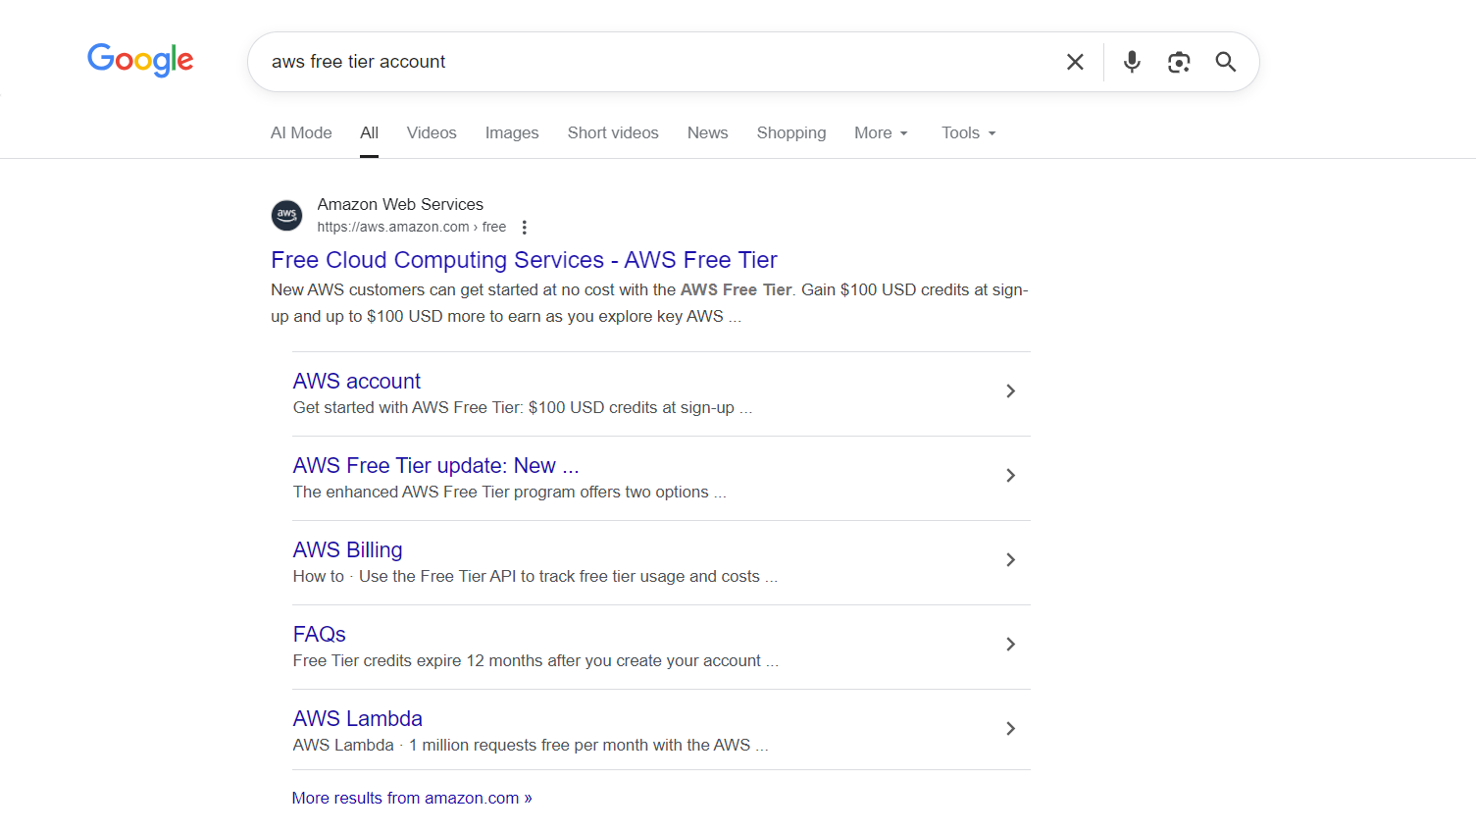

- Create a New AWS Account:
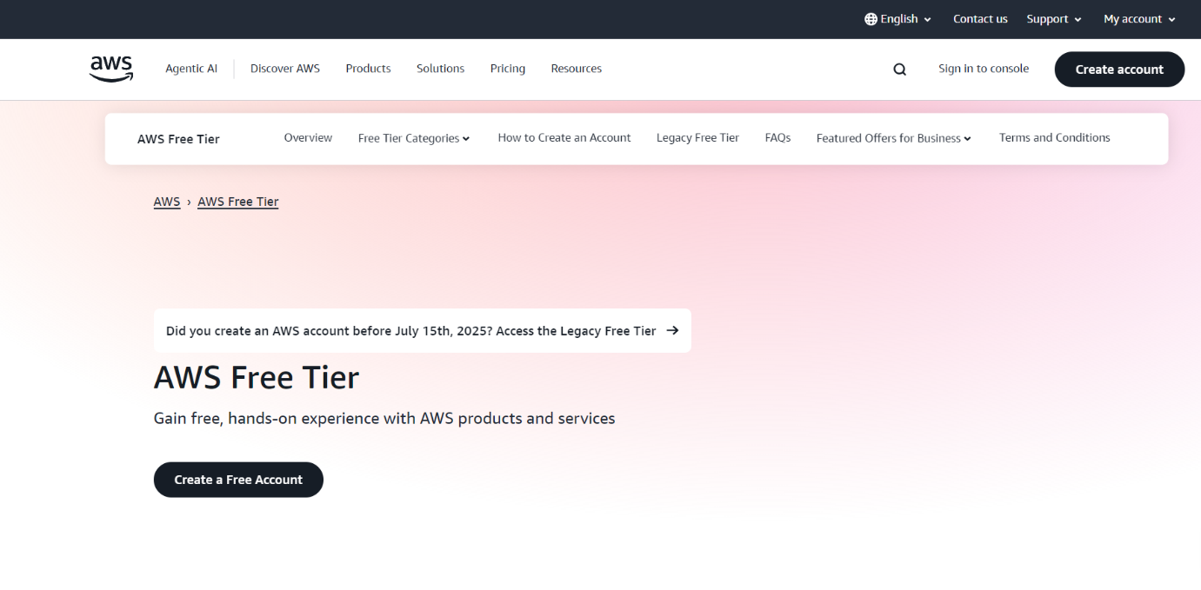
- Click on “Create a Free Account”.
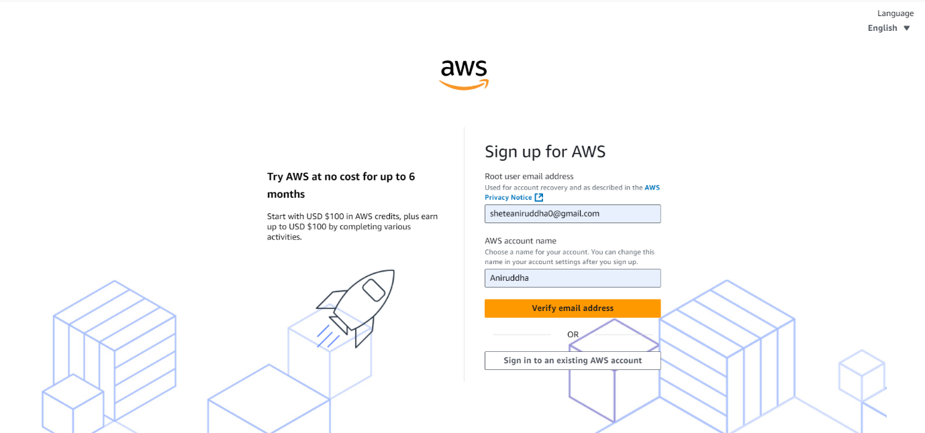
- Enter your address and account name.

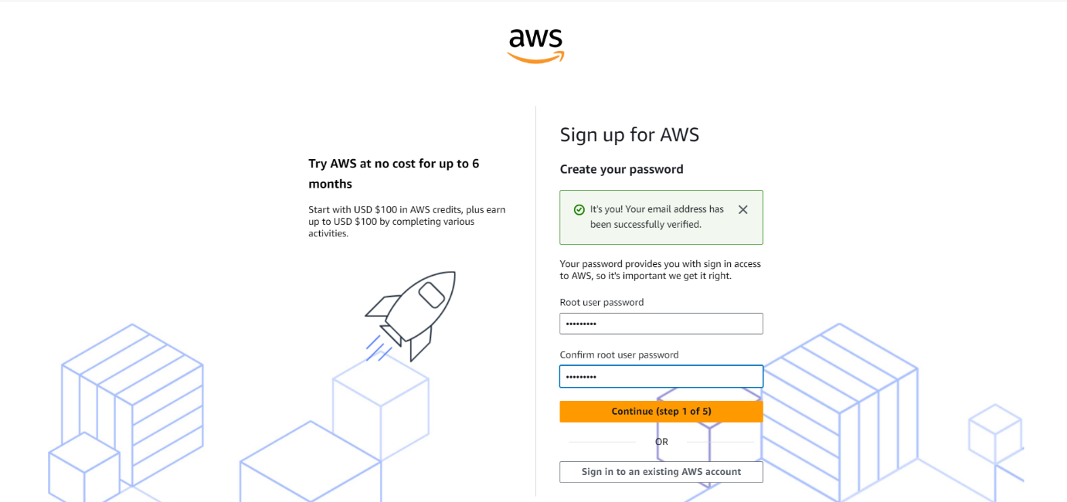
- Enter the verification code received on your provides email address.

- Create password for root user and click on continue.
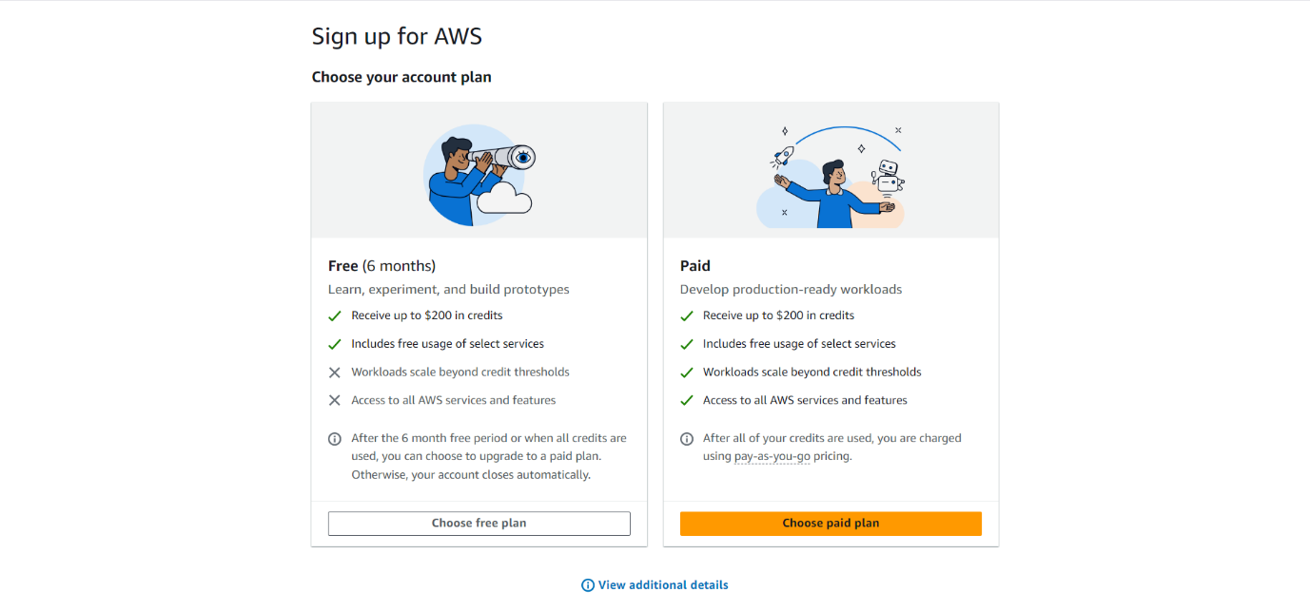
- Choose Free Plan.

- Provide Contact Information:
- Enter your contact details, including phone number and address.
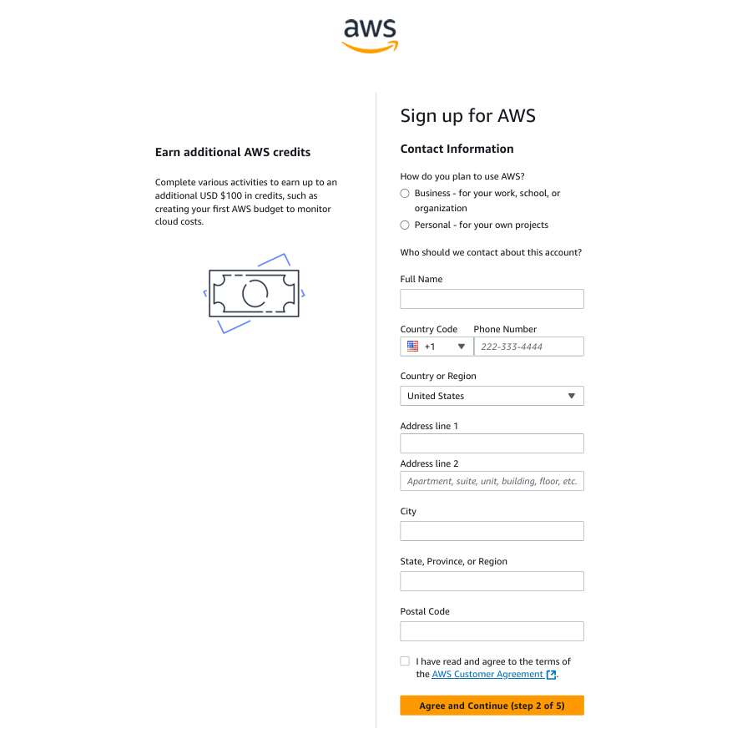
- Verify your phone number via a text message or voice call.

- Enter Payment Information
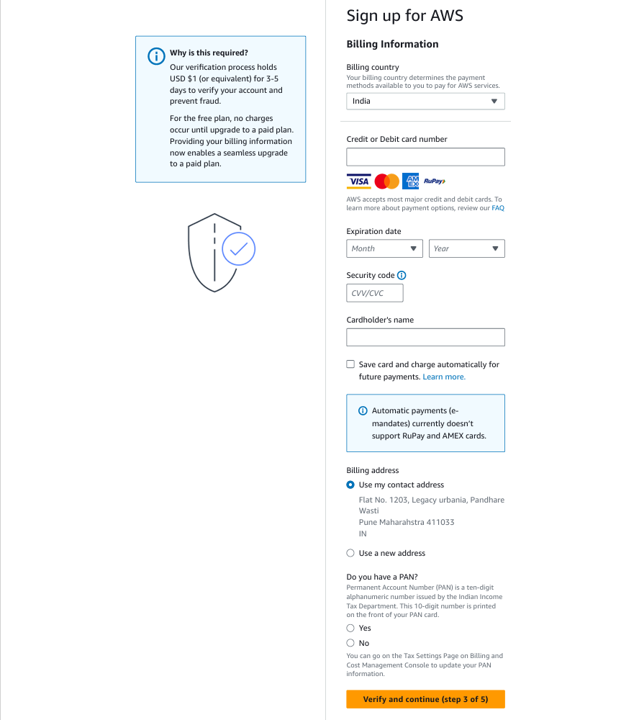
- Enter payment information for debit card. AWS requires a payment method for verification purposes.

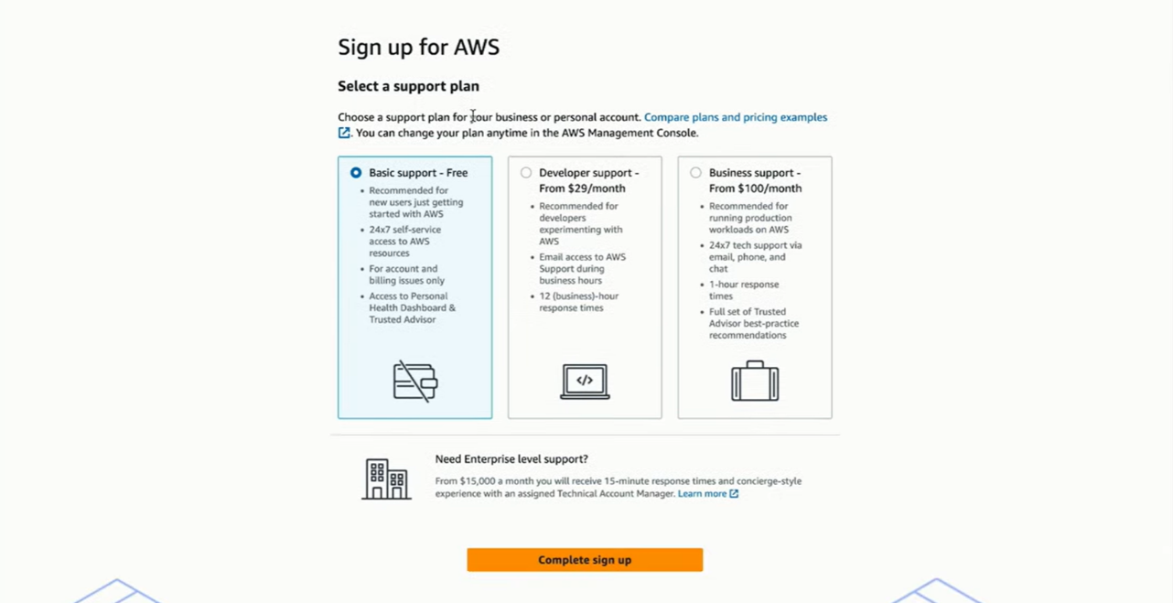
- Choose a Plan.

- Identity verification
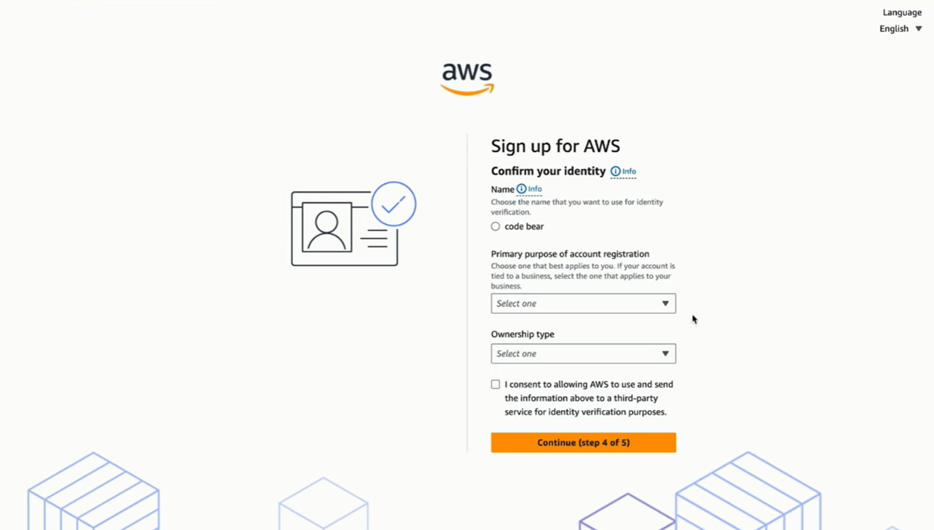
- Verify your identity using verification code sent to your mail or phone.

- Complete Registration
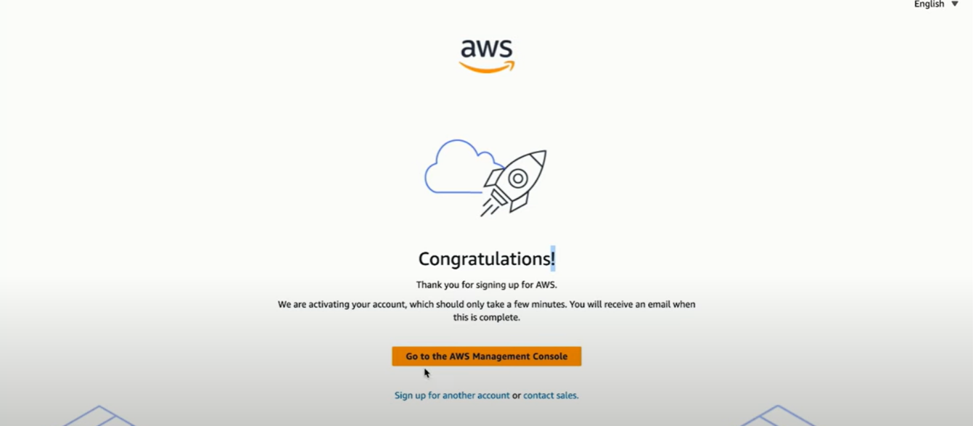
- After verification, you can log in to the AWS management console.

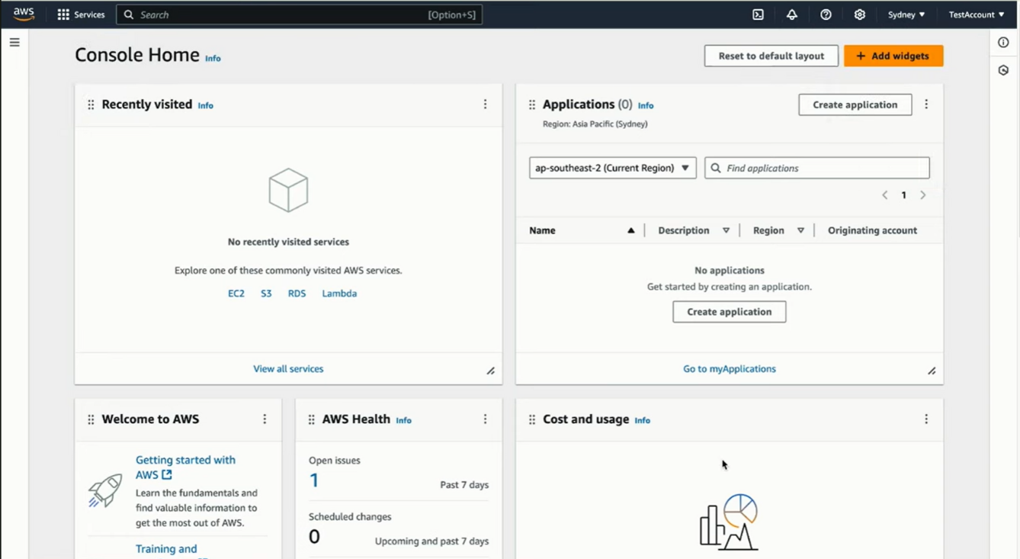
- The AWS Free Tier offers 6 months of free access to many services (like EC2, S3 and Lambda) with limited usage.

Aim: Creating and Managing IAM Groups and User Permissions
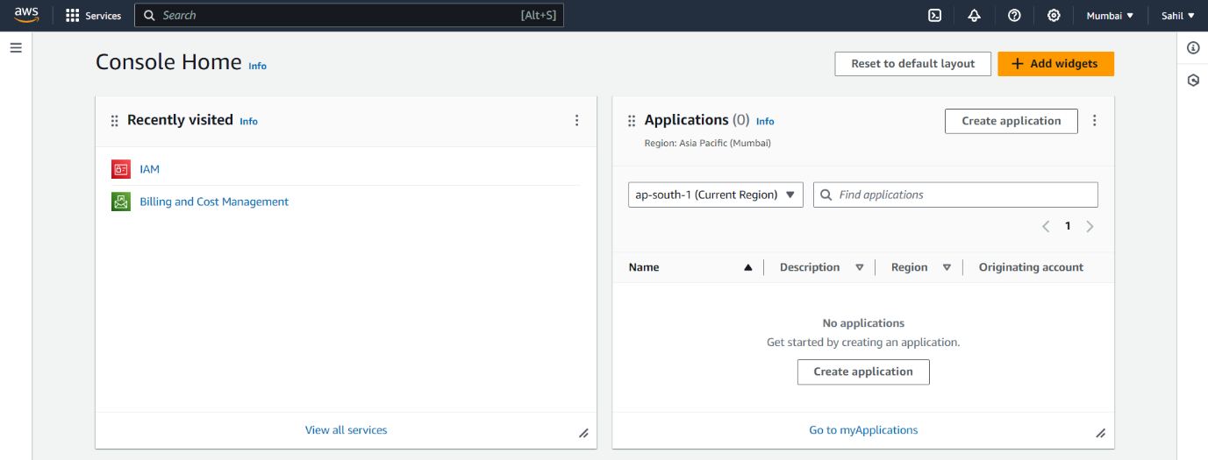
Step 1: Sign in to AWS console and open IAM.

Step 2: Go to user in Access Management Panel in IAM.
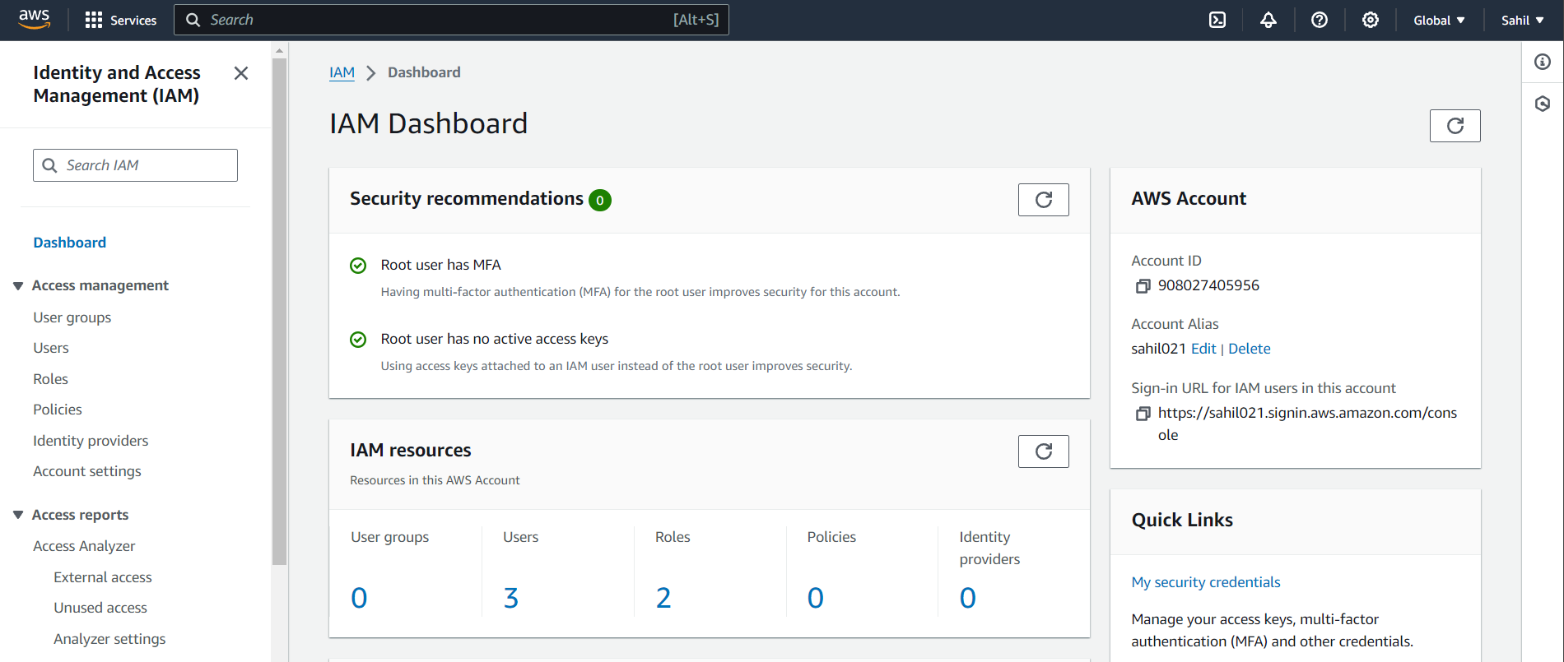

Step 3: Select Create User.
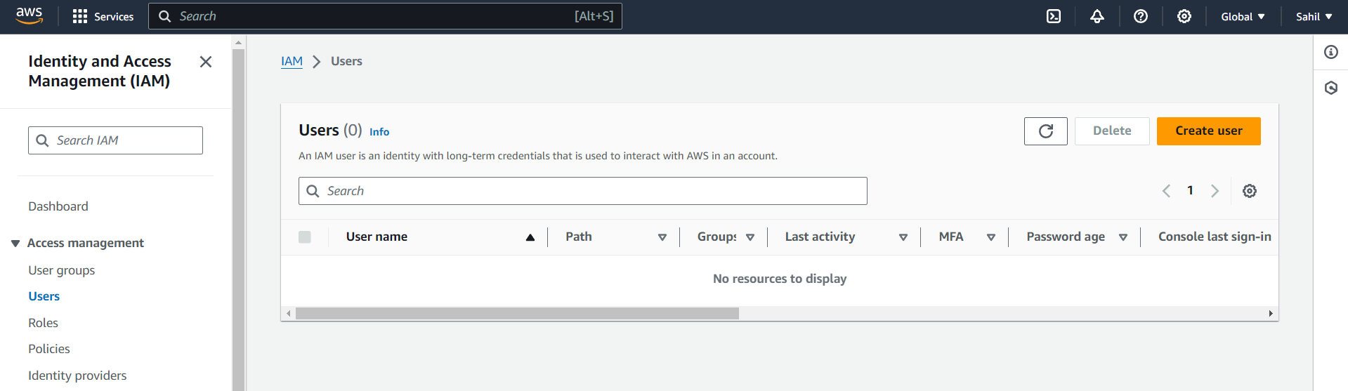

Step 4: Enter User Details. (Neil)
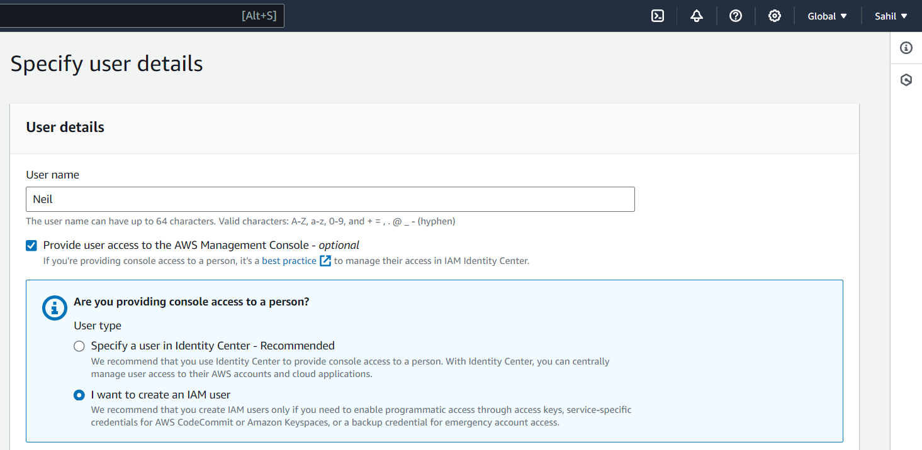

Step 5: On Permission Page, choose attach Policies directly. Search and select the policy “S3 Full Access”. Review and create the User.
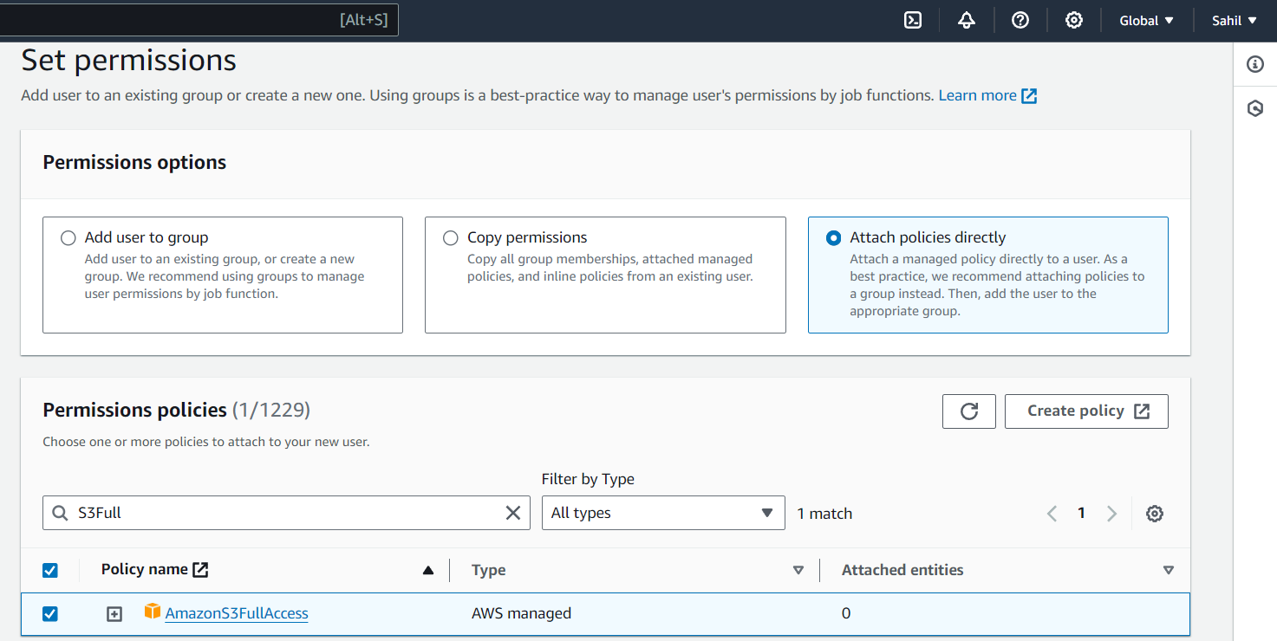

Step 6: Repeat Same steps for other 2 users (Nitin And Mukesh) and give them permissions of EC2 (Full Access) and IAM (Full Access) respectively.

Step 7: Test Cross user Permissions. Login As ‘Neil’.

Step 8: Try to Access EC2 Resource via EC2 Console. Since Neil has only S3 access, so he is not able to access or manage EC2 resource.

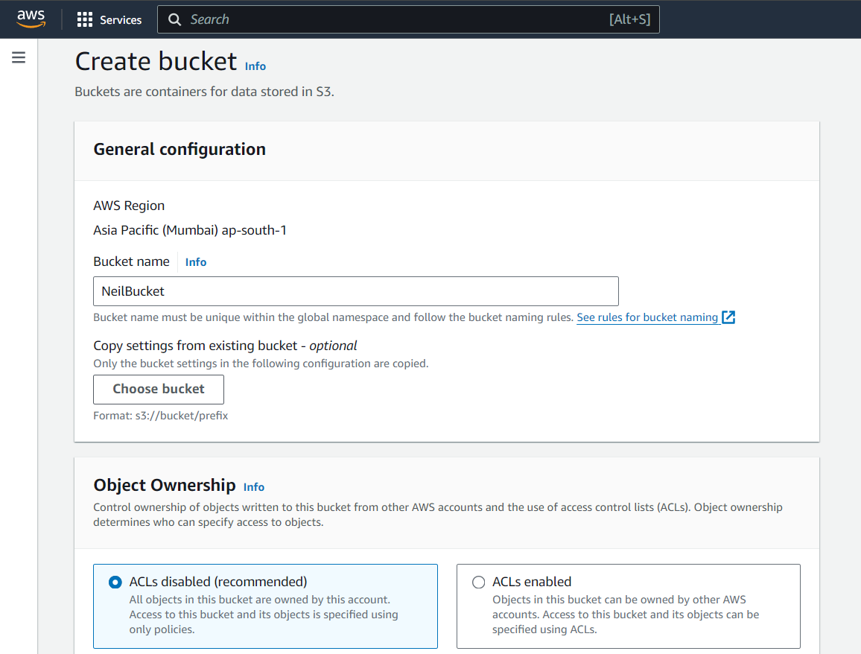

Similarly, Mukesh cannot login to S3 and EC2 Consoles since Mukesh has full access of IAM, he is able to create and manage IAM users.

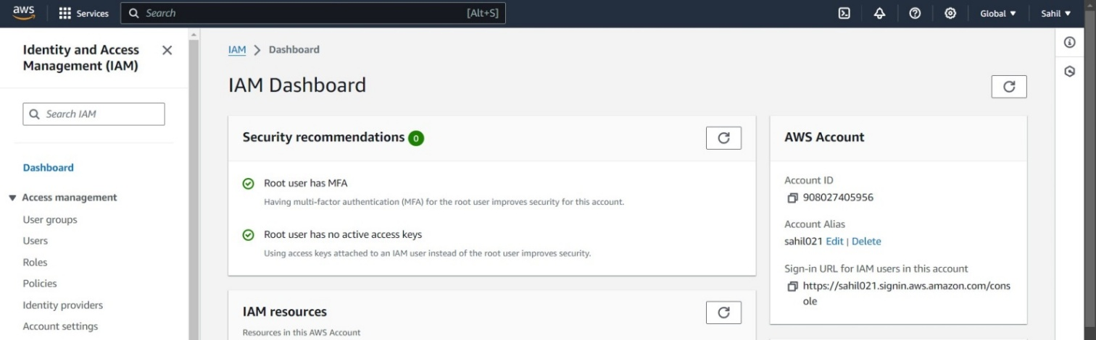
Step 9: Navigate to IAM (type "IAM" in the services search bar).

Step 10: In the left sidebar, click on Groups.
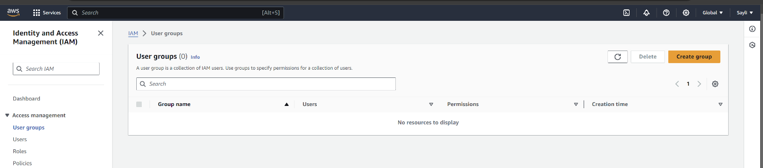
Step 11: Click the Create New Group button.

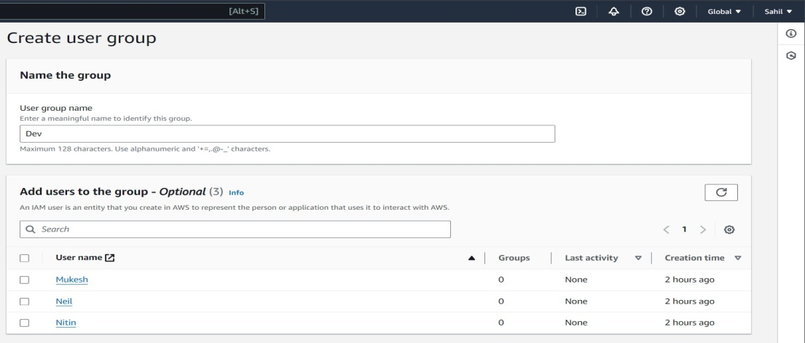
Step 12: Name the first group:- Enter `Dev` and click Next Step.

Step 13: Attach Permissions:
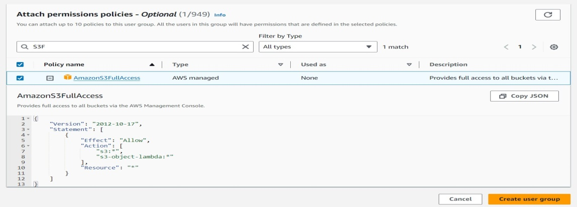
- Select permissions, in our case S3FullAccess.
- Click Next Step, review, then click Create Group.

Step 14: Repeat the process for the `Test` group:
- Click Create New Group.
- Enter `Test` and click Next Step.
- Attach permissions.
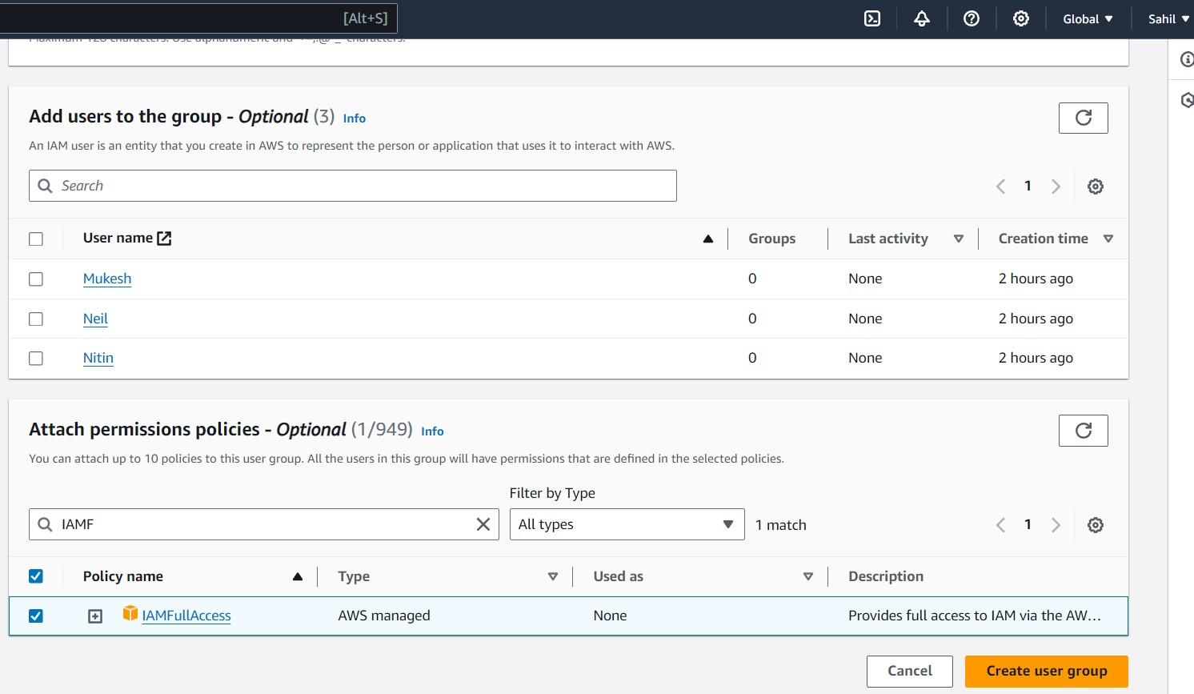
- Click Next Step, review, then click Create Group.

